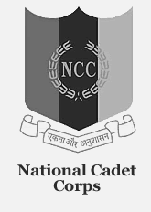
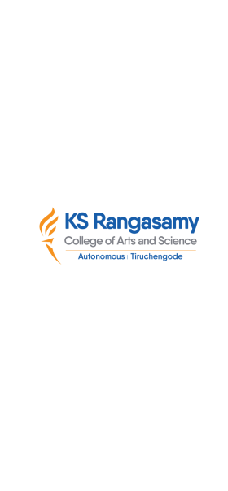
natIonal cadet corps, 12 (TN) BN NCC, Salem -16
K S R College of Arts and ScIence (autonomous)
NCC (ARMY WING), TIruchengode – 637 215

DRUG-AWARENESS RALLY
OUR KSRCAS-NCC Cadets Attend “DRUG AWARENESS RALLY” On 26.06.2023, 24 Cadets Of K.S.Rangasamy College of Arts and Science and ANO Capt.A.Kesavamoorthy were attend this “ Drug Awareness Rally” At Tiruchengode Girls High School,Tiruchengode.
