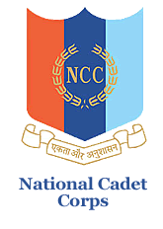

**natIonal cadet corps, 12 (TN) BN NCC, Salem -16**

**K S R College of Arts and ScIence (autonomous)**

**NCC (ARMY WING), TIruchengode – 637 215**

**ELECTION AWARENESS RALLY**

Our KSRCAS-NCC haveconducted a “**ELECTION AWARENESS RALLY”** from **Tiruchengode Girls Higher Secondary School to Valaraigate** on 13.03.2024. Our KSREI **CEO** Akhila Muthuramalingam Inaugurated the rally with **SUB-INSPECTOR** ThangamTown Police Station Tiruchengode. It Created Awareness about the Importance of VOTE.

