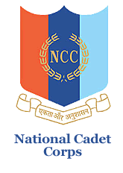

**natIonal cadet corps, 12 (TN) BN NCC, Salem -16**

**K S R College of Arts and ScIence (autonomous)**

**NCC (ARMY WING), TIruchengode – 637 215**

**INTERGROUP COMPETITION (TSC)**

Our Cadet **CDT.S.SHRISHANTH** have attended the “**INTERGROUP COMPETITION (TSC)”** which was held at Dhanalakshmi College Of Engineering on 16.07.2023 to 25.07.2023.

