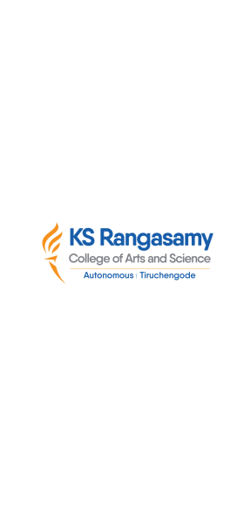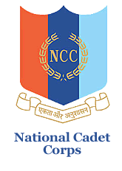

**natIonal cadet corps, 12 (TN) BN NCC, Salem -16**

**K S R College of Arts and ScIence (autonomous)**

**NCC (ARMY WING), TIruchengode – 637 215**

**ROAD SAFETY AWARNESS PROGRAM - 2024**

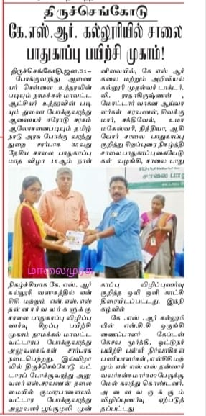 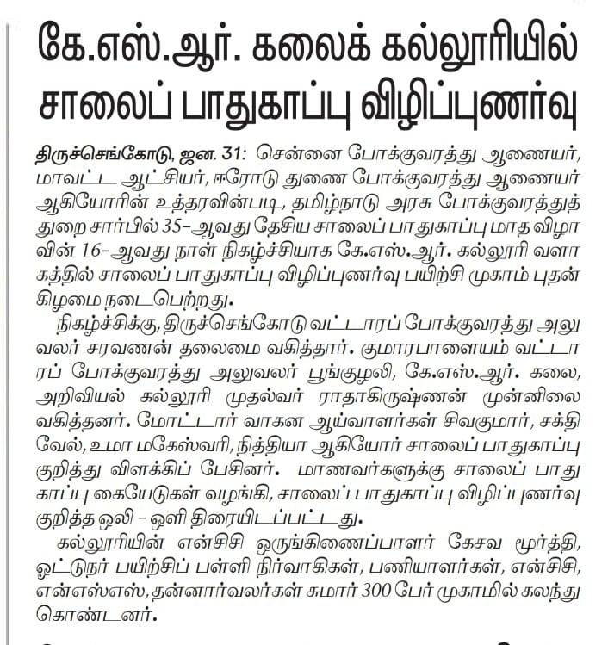

Our KSRCAS-NCC had conducted the Road Safety Awareness Month program on 30.01.2024 at KSREI. This awareness program delivered the Interaction among the NCC Cadet’s and Student’s by Tiruchengode Regional Transport Officer Mr.S.SARAVANAN and other RTO’s of Namakkal district. This conversation gives the valuable lesson to the NCC Cadet’s and student’s .