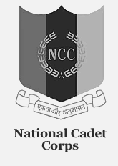
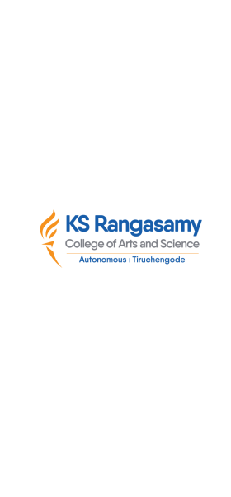
natIonal cadet corps, 12 (TN) BN NCC, Salem -16
K S R College of Arts and ScIence (autonomous)
NCC (ARMY WING), TIruchengode – 637 215

SABARIMALAI SERVICE – 2023

Our Cadet’s has attended the “SABARIMALAI SERVICE CAMP” which was held at Sabarimalai on Dec 2023 by Joining with AKHILA BHARATHA AYYAPPA SEVA SANGAM to serve the people’s.
