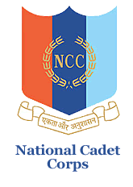

**natIonal cadet corps, 12 (TN) BN NCC, Salem -16**

**K S R College of Arts and ScIence (autonomous)**

**NCC (ARMY WING), TIruchengode – 637 215**

**SWACHH BHARAT MISSION**

Our KSREI NCC and NSS Volunteers have Conducted a **“SWACHH BHARAT MISSION”** with the combined of Tamilnadu Forest Department at Sathiyamangalam Reseve Forest Area on 09.12.2023.In this regard 30 NCC Cadet’s and Capt.A.Kesavamoorthy (ANO OF KSRCAS-NCC) of K.S.Rangasamy College of Arts and Science (Autonomous) being a part of Participating this mission and cleaning the reserve forest area to be protect to Wild animals.

