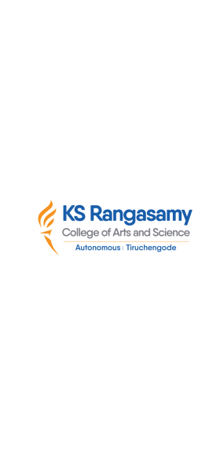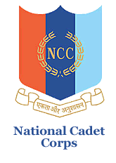

**natIonal cadet corps, 12 (TN) BN NCC, Salem -16**

**K S R College of Arts and ScIence (autonomous)**

**NCC (ARMY WING), TIruchengode – 637 215**

**YOGA DAY CELEBRATION**

Our KSRCAS NCC Cadets attend “**INTERNATIONAL YOGA DAY CELEBRATION**” on 21.06.2023. Our 12 (TN) BN NCC Cadet’s of various colleges has attended the Yoga Day Celebration at K.S.R Educational Institution.

